Abstract submission form

Presenting author:

Name: ……………. Surname: …………..

Affiliation: ……….

- Senior
- PhD Student
- MS Student

Authors are requested to indicate
their preferred presentation type
⧠ Oral
⧠ Poster
their participation of choice
⧠ in person
⧠ virtual

Please select at least one of the following topics:
- Applications of oxide electronics
- Novel conducting oxide interfaces
- Magnetic, ferroelectric and multiferroic oxide materials
- Structural and electronic properties of nickelates, vanadates, cobaltates...
- Designing novel properties and functionalities in oxide films, heterostructures or interfaces
- Superconductivity in oxides
- Spin orbit coupling effects
- Topological oxide insulators and superconductors
- Advanced characterization techniques applied to oxide films and heterostructures
- Recent theoretical developments
- Oxide MEMS & NEMS
- Oxide membranes

Title of the Abstract (Times New Roman 14 pt; bold)
Authors Name¹, …, Authors Name^{n} (Times New Roman 12 pt)
¹ Author 1 affiliation (Times New Roman 12 pt; italic)
^{n} Author n affiliation (Times New Roman 12 pt; italic)

All the submitted abstracts will be published in the “iWOE27 Book of Abstracts”.
This template represents a compendium of general style rules to help authors when preparing an abstract for iWOE27. It is used to format your abstract and style the text; all margins, column widths, line spaces, and text fonts are prescribed; please do not alter them. You may type over sections of the document, cut and paste into it. Later on it will be converted into Portable Document Format (PDF).
Duplicate this template file by using the “Save As” command and save it using the first author surname, that is as “Surname.docx”.
All characters must be “Times New Roman” or, where required, “Symbol”. Equations along the text can be also inserted using “MathType”.
The abstract must 1 page long at maximum, including the Figure (optional) and References. It is expected that authors will submit carefully written and proofread material. Avoid unexplained acronyms; all nonstandard symbols and abbreviations must be defined.
For the Title, capitalize only proper or trade names and chemical symbols; the use of non-standard abbreviations and acronyms should be avoided.
In the authors’ affiliation, write out the names and postal addresses of all institutions in full.
The figure must be inserted as image file in the table below, following the instructions therein reported.
Please, insert the Figure here as an image file; use 1 single image file
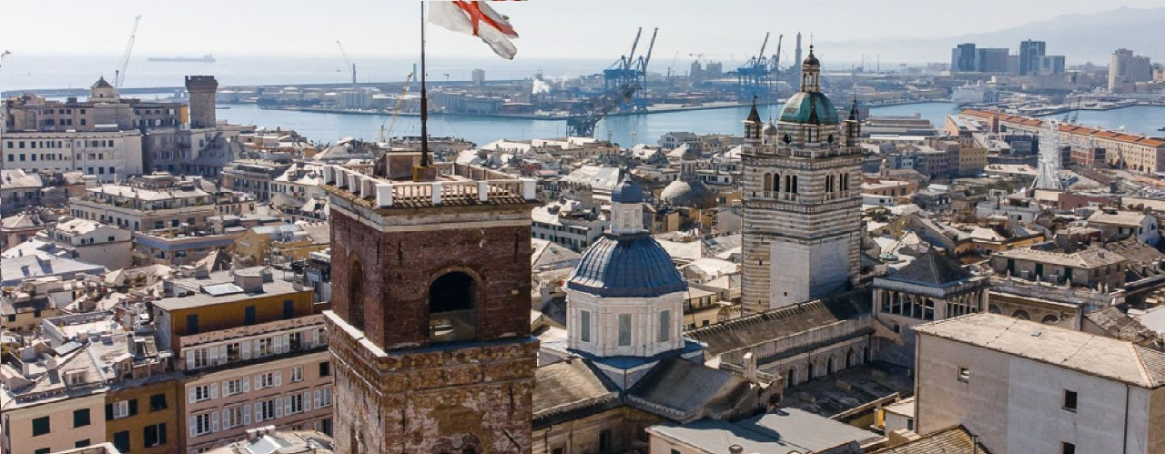
Figure caption (Times New Roman 10 pt): It is possible to combine different images to produce 1 single image file.
In the body of the paper all references must be indicated by consecutive numbers contained in squared brackets along the text and listed at the bottom of the page as illustrated below [1,2]. Journal names are abbreviated (standard journal abbreviation) in the list of references that appears at the end of the manuscript.

References (Times New Roman 10 pt; bold)
[1] A. Blanc, C. Red, M. Green, J. Superfox 10 (2020) 100
[2] T. Brown et al.,Superfox Review 150 (2015) 57

